Performance Testing
Date | 01 October 2026
Team ID | SWTID-2026-2351
Project Name | Auto Ticket Classification using Flow Designer
Maximum Marks | 5 Marks

Step 1: Testing Overview
Testing Tool Used | ServiceNow Flow Designer Test and Flow Execution details; Email Log (sys_email)
Type of Testing | Functional run-time check of one ticket at a time (light load)
Target Module / API | Flow "Auto Classify School IT Tickets" and the Send Email action
Test Environment | ServiceNow Personal Developer Instance (cloud)
Test Date | 29 September 2026

Step 2: Test Scenarios
S.No | Test Scenario / Description | No. of Virtual Users | Duration (sec) | Expected Outcome
1 | Create a ticket with Short Description about Wi-Fi and empty Category | 1 | Record the time in Flow Execution | Category = Network, Subcategory = Wi-Fi
2 | Create a ticket about the projector | 1 | Record the time in Flow Execution | Category = Hardware, Subcategory = Projector
3 | Create a ticket about a forgotten password | 1 | Record the time in Flow Execution | Category = Access, Subcategory = Forgot password
4 | Create a ticket about a slow computer | 1 | Record the time in Flow Execution | Category = Performance, Subcategory = Slow computer

Step 3: Performance Test Results
Enter the measured values from the Flow Execution and Email Log screens. No timing values were provided with the screenshots, so the Actual Value column is left for you to fill.
S.No | Metric | Target Value | Actual Value | Status (Pass / Fail) | Remarks
1 | Response Time (Avg) | < 2 seconds
2 | Response Time (Max) | < 5 seconds
3 | Throughput (Req/sec) | n/a for single-user test
4 | Error Rate | < 1% | 0 errors seen in the run shown | Pass | Flow executed and email generated
5 | CPU Utilization | < 80% | Managed by ServiceNow | n/a | Platform-managed
6 | Memory Utilization | < 80% | Managed by ServiceNow | n/a | Platform-managed

Step 4: Observations & Analysis
- The flow runs when a record is created with an empty Category and updates Category and Subcategory.
- The confirmation email "Your IT ticket has been successfully submitted and classified." appears in the Email Log.
- Load is a handful of tickets per day in a school, so heavy load testing is not needed.

Step 5: Screenshots / Evidence
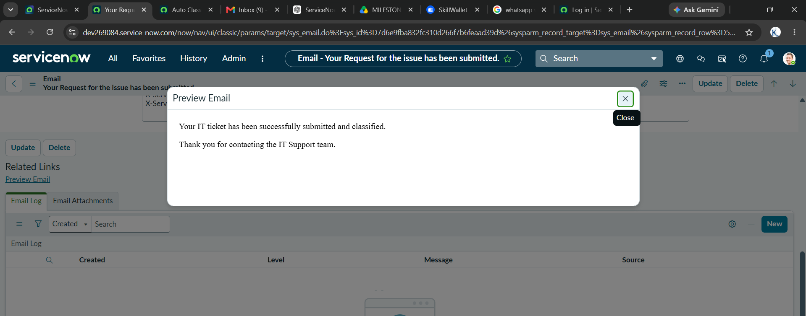
Figure 1: Email preview from the Email Log
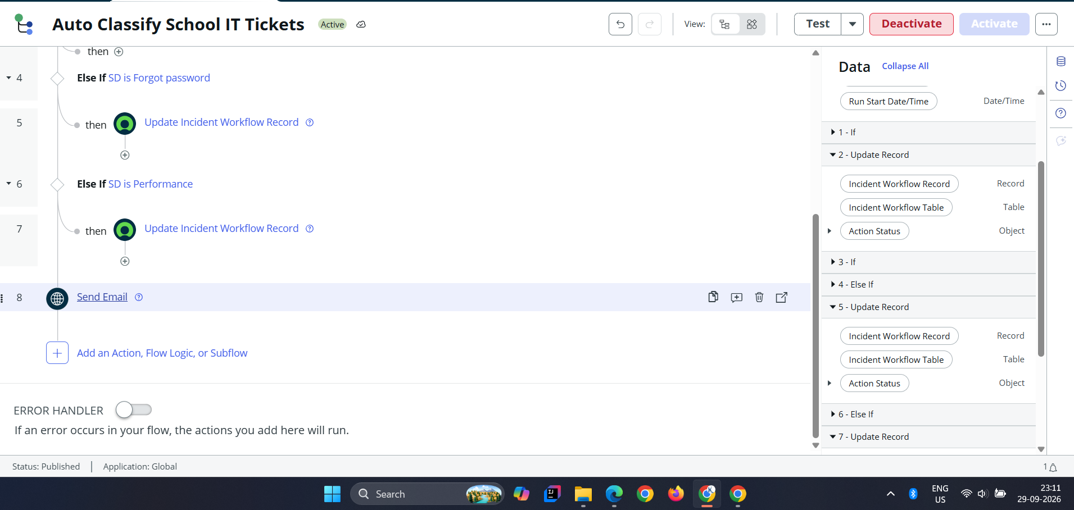
Figure 2: Flow with Send Email action (Status: Published)

